ELCT 201 – EE Laboratory 3

Motor Current, VOltage, and Power

Jacob Vaught
9/28/2022

Department of Electrical Engineering
University of South Carolina
Columbia, SC 29208

Abstract
This lab teaches oscilloscope trigger settings, current-source mode for power supplies, determining an appropriate resistive sensor for motors, designing appropriate low-pass filters, and understanding the relationship between torque and current for brush-type DC motors.
SPICE simulations were not included in the paper due to the circuits’ simplistic design and due to the fact that SPICE does not currently have a motor object to simulate.

Introduction
This motor is a brush-type permanent magnet DC motor. It converts electrical power to mechanical power, but is less efficient than other similar methods, such as synchronous AC Motors. The motor current is measured by connecting a resistor in series with the motor and measuring the voltage across the resistor. Due to this, the choice of resistor values is crucial to a accurate result. The resistance should be small enough to not affect the circuit, but large enough to measure the voltage across it. Due to the motor being a brush-type motor, when measuring the current, the waveforms will contain noise due to how the motor operates. Thus, a RC filter is used to remove any noise over 50 Hz.

PRE-Lab

Current Measuring ResiStor value
The goal of the prelab was to calculate an appropriate current sensing resistor size for the motor. It is given that the motor draws 100 mA when 10 V is applied at 0 load and draws 300 mA when a load is applied at the same voltage. To determine the needed resistance, an arbitrary voltage of 0.25 V was chosen for the minimum detectable voltage for the oscilloscope. The minimum resistance can be solved for with Eq 1 and Eq 2, and results in a value of 2.56 Ω.
The maximum voltage of the resistor should be restricted to 10% of the input voltage, which can be modeled by Eq 3. Solving the equation results in 3.7 Ω.
After consulting a table of common resistor values, a 2.2 Ω resistor meets the requirements most adequately. The power rating of this resistor can be calculated via Eq 4, and results in 0.174 Watts, thus a rating of 0.25 Watt would be most appropriate.

Low-Pass Filter
The second part of the pre-lab discusses the effect of a RC filter on the circuit and what a potential low-pass filter would be composed of. The formula for a low-pass filter is Eq 5, and since the cutoff frequency is known, there remains 2 variables to be solve for. A value for the capacitor is arbitrarily chosen at 0.1μF, leaving only resistance to be solved for. Plugging these values into Eq 5, it can be determined that a resistor value of 33 kΩ is suitable.

Torque Coefficient
The final part of the prelab inquires about the value of the torque coefficient, k, given some constraints. The constraints are I=150mA, mass=0.1 kg, radius=0.05m, g=9.81 m/s², and after plugging into Eq 6, it can be determined that k=0.327.

In-Lab

Motor current
The circuit built in the lab includes a 10 Ω resistor in series with the motor. After setting the DC Power supply to 10 V, the motor started to rotate. The oscilloscope output can be seen in Figure 2. Although the input voltage is DC, the voltage measured across the current-measuring resistor is more similar to AC signals. Figure 3 shows the signal in more detail.
After applying a load to the motor, the current increased dramatically, as can be seen in Figure 6 and Figure 4.

RC(LoW-PASS) Filter
Due to the brushes on the motor, it is rather difficult to get a consistent current measurement, thus a RC, Low-Pass filter was used. A 100 kΩ resistor was used in series with a 0.1uF capacitor to create a RC Low pass filter. This filter was used in parallel with the current measuring resistor. The results of the RC filter on the current waveform are visible in Figure 6 and Figure 5.

Measure motor Torque
The goal of this section is to measure the torque of the motor and the current. This is completed via placing a weight on a string which is connected to a wheel with a 5cm radius. Measurements of current, time and voltage were taken at many different weights to get a more accurate result. The collected data is shown in Table 2. As can be seen from the table, the k value drops as load decreases, and the efficiency is 33%, which is quite low for a DC motor, which generally ranges from 70%-90%.

MOTOR SPEED VS vOltage
Finally, motor speed is dependent on voltage, as stated by Dr. Dougal multiple times during lecture, and this was tested in the lab and show to be true. A doubling in voltage was roughly equivalent to a doubling in motor speed. This data can be viewed in Figure 1 and Table 1.

Appendix
All Figures, Tables, and Equations are below.

Figures

Figure 1 shows the relationship between voltage and motor speed.

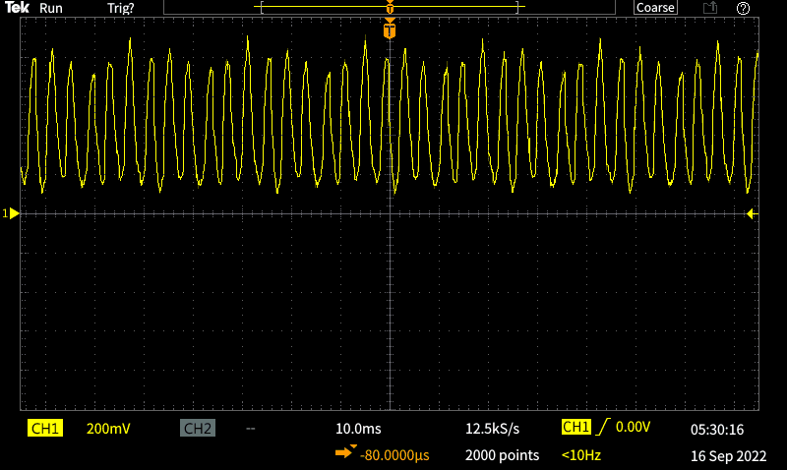
Figure 2 shows the voltage signal across the current measuring resistor. Note the choppiness of the signal.

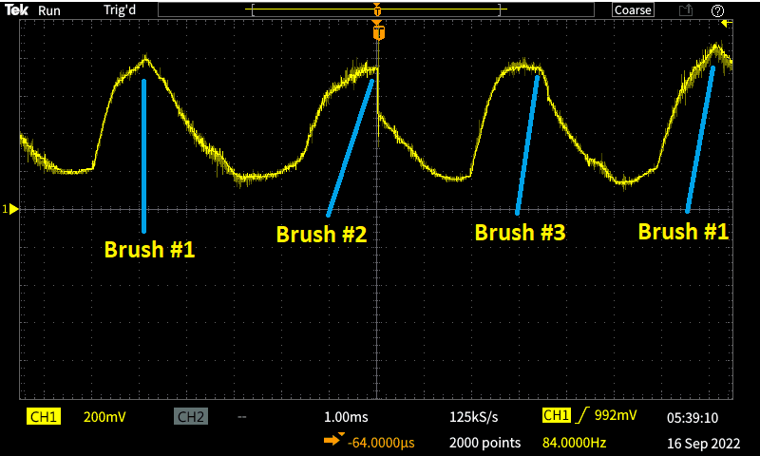
Figure 3 shows a closeup shot of the motor signal.

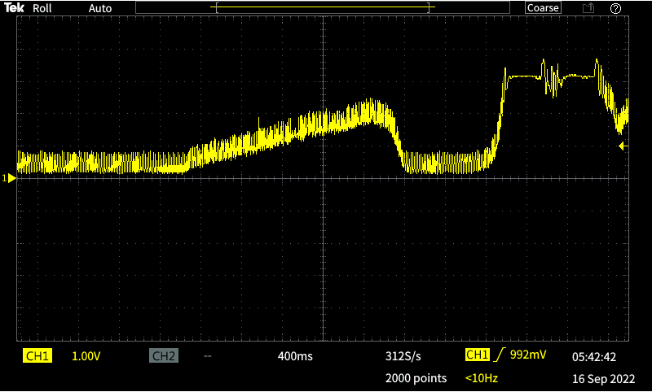
Figure 4 depicts the voltage measured across the resistor while a load is being applied

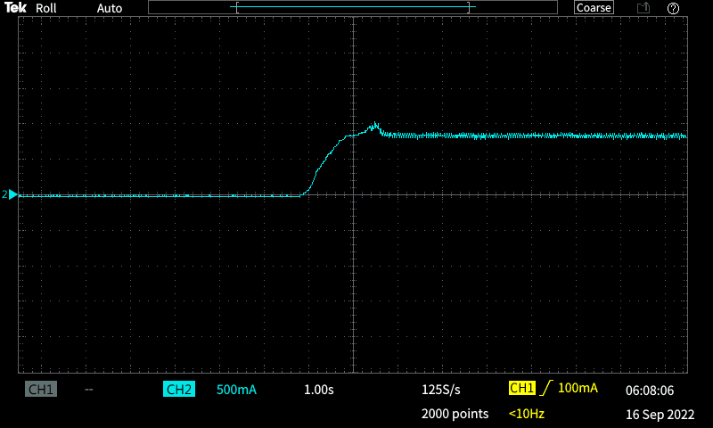
Figure 5 depicts the current going through the motor as it is being turned on. The current is measured after going through a RC filter.

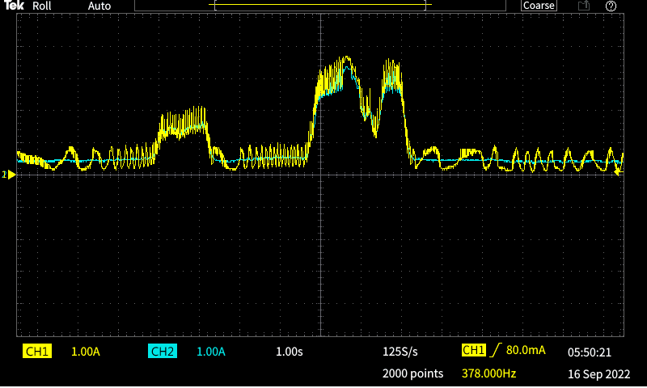
Figure 6 depicts the current and voltage. The current is being measured through a RC filter.

Tables
Voltage | Time | Speed
5 | 10.65 | 1.877934
7.5 | 6.22 | 3.215434
10 | 4 | 5
Table 1 shows the tabulated data from the experiments

 | 500g | 250g
Current | 150mA | 90mA
Time | 9.8s | 7.52s
ω | 2.040816 | 2.659574
Torque | 0.24525N*m | 0.122625N*m
Power | 0.50051 W | 0.32613 W
P_{e} | 1.5 W | 0.9 W
η | 0.333673 W | 0.362367 W
k | 1.635 | 1.3625
Table 2 depicts the calculated and tabulated data referring to Motor torque, efficiency, k-value, etc.

Equations
$V_{out}=V_{in}\left(\frac{R}{R+R_{motor}}\right)$ (Eq 1)
$R_{motor}=\frac{I}{V}$ (Eq 2)
$0.1*V_{in}=V_{in}\left(\frac{R}{R+R_{motor}}\right)$ (Eq 3)
$P=\frac{{\left(V_{in}\left(\frac{R}{R+R_{motor}}\right)\right)}^{2}}{R}$ (Eq 4)
$f=\frac{1}{2πRC}$ (Eq 5)
$T=k*I=m*r*g$ (Eq 6)

